Time for mutex

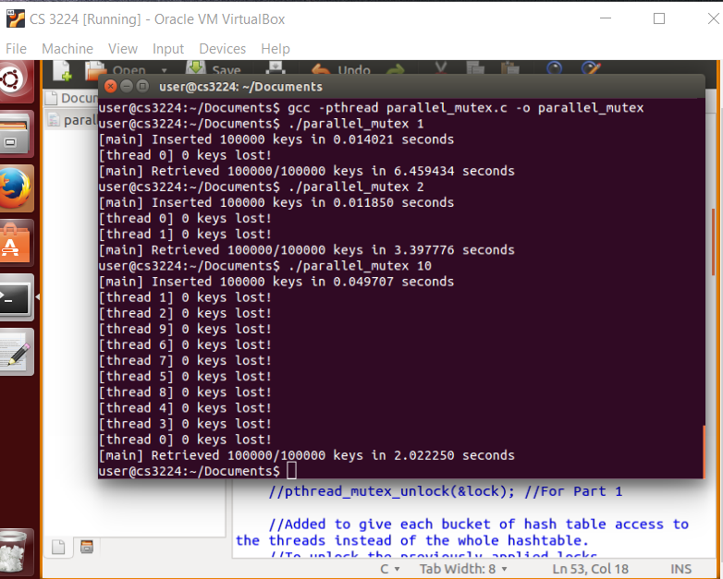

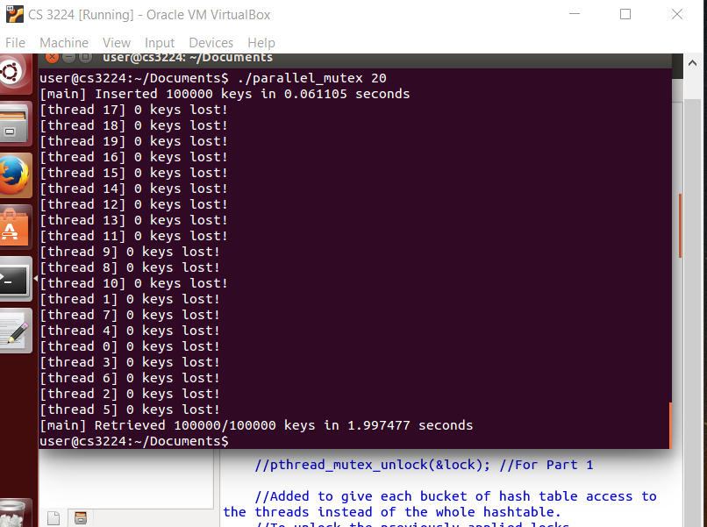

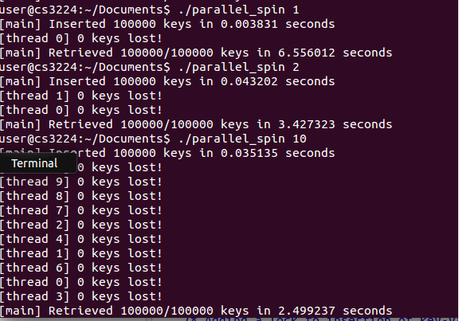

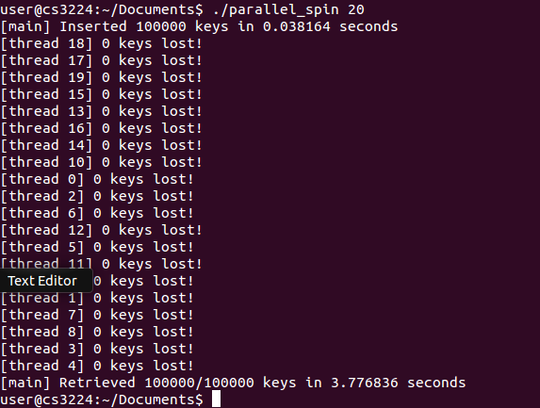

For 50 threads:

Mutex : insert – 0.047573 retrieval – 2.798292

Spin: insert – 0.038286 retrieval – 3.361384